VoiceGpt Bot

**Description**:

VoiceGPT is an innovative project that allows users to interact with an AI through voice commands and receive responses in a realistic AI-generated voice. By converting voice to text and leveraging advanced language models. VoiceGPT converts voice to text, processes it with GPT for response generation, and returns the generated response as voice.

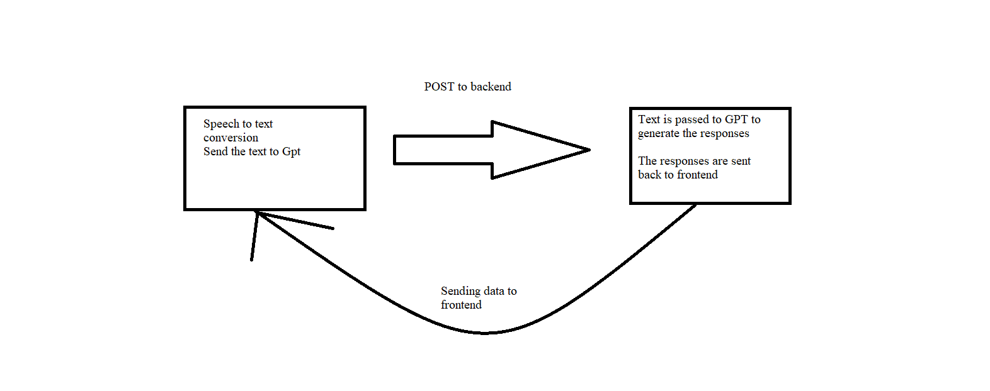

**Dependencies Used:**

To install the necessary Node.js packages for the audio recording and transcription application with OpenAI's Whisper API, the following packages are used:

1. **openai**: The official OpenAI Node.js package that facilitates interaction with OpenAI's API, including the Whisper Speech-to-Text API. It grants access to the Whisper API for audio file transcription.

In the backend I have used OPEN AI api to generate the response from the text.  
  
The voice is received and converted to text in frontend and then that text is sent to backend for GPT interaction using POST method. Further the text is spoken in frontend using windows.speech.synthesis.

**Code Flow:**

1. On click of mic button Speech to Text websocketrecognition starts and do the required conversion.
2. The transcript generated is sent to backend
3. There the text is passed to GPT 3.5 turbo for responses
4. Then the text is received in frontend and converted to Speech using function speakBot(String text)

***Note from Developer:” It was the great experience, learned a lot and also going to explore other projects after this submission.”***